 | International Civil Aviation Organization  WORKING PAPER
  NSP CSG WP-44
  05/19/2014

NAVIGATION SYSTEMS PANEL (NSP)

CSG Meeting
May 19-21, 2014

Agenda Item 3a | : | GAST D Operational Validation

SARPS for GNSS elements and signals (GBAS)

WORKING PAPER

FAA GBAS GAST-D SARPs Validation Tool

Presented by Ken Alexander

(Prepared by Shawn Casler (FAA))

SUMMARY
The FAA has created a GAST D SARPs online validation tool. The FAA plans to use this tool in tracking the validation status of the GAST D SARPs. This paper contains a description of the tool in the form of a users manual. The tool is offered for use by the CSG as part of its validation activities.

1 GAST-D Online Validation Database Tool Overview

The SARPs Online Validation Database Tool is an FAA designed website and database intended to be used in FAA tracking of the validation of the GAST D SARPs. The website is located at http://laas.tc.faa.gov/sarps.html.

The database has been populated with the GAST D SARPs baseline requirements and material from the CSG Validation Matrix [1, 2]. The database contains an individual entry for each ‘shall’ in the GAST D proposed SARPs. A team consisting of FAA and GBAS Key Technical Advisors (KTAs) are assigned as Points of Contact (POC) to each individual requirement and that person will be responsible for completing documentation of the validation, including considering any comments received. All users will be able to leave comments once they are registered to use the tool.

The remainder of the paper is a user’s guide that explains how the tool functions.

2 SARPs Main Page

- Go to http://laas.tc.faa.gov/sarps.html

- For tutorial purposes, we will be using a read-only default account:
  - Username: guest
  - Password: faa

- When creating an account, click the provided link to create an account for immediate access.

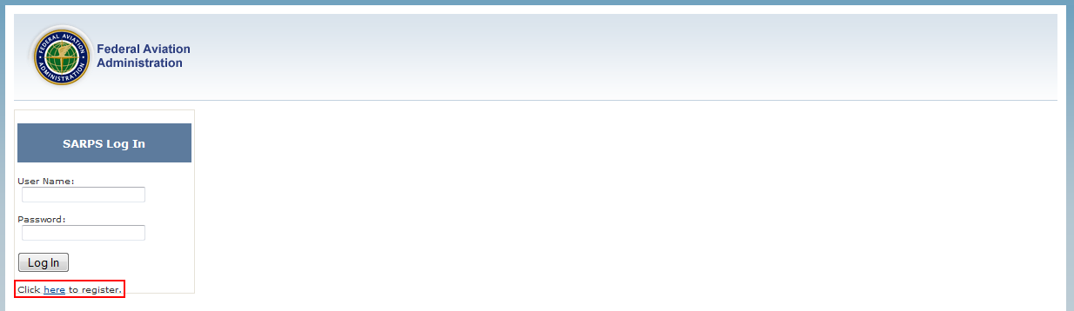

- Fill out the form provided.

- Your first and last name all lower case and concatenated together will be your username
  - Example: John Smith’s username would be johnsmith

3 Tab One – SARPs Validation

- The first two areas highlighted in the red boxes shown below, denotes the search parameters.
  - The top box displays the selected version of the SARPs PDF the user will be viewing.
  - The second box displays the options to limit the search results, which is optional. All contains GBAS as well as SBAS, GPS, etc. So users can limit the entries to only GBAS, only GAST D requirements, or those needing Operational Validation (Ops Val).

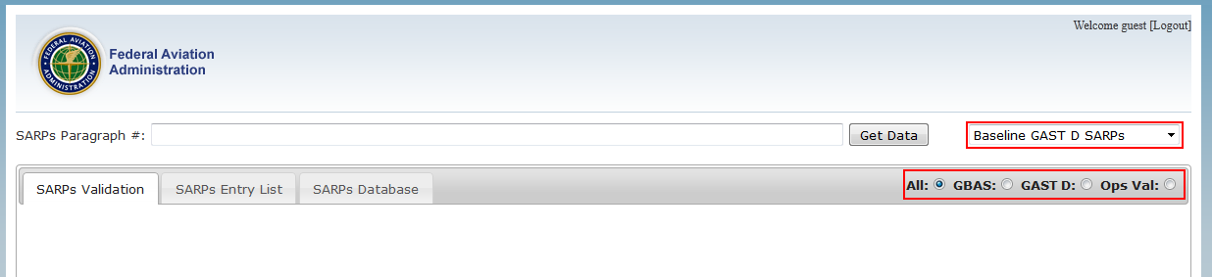

- Next is the search function for the SARPs Paragraph #. The red box shown below is where users can enter the title or paragraph number of the specific requirement. As users type, an autocomplete function will display the entries that contain a partial subset. Once selected, the requirement shows up in the SARPs Validation tab.

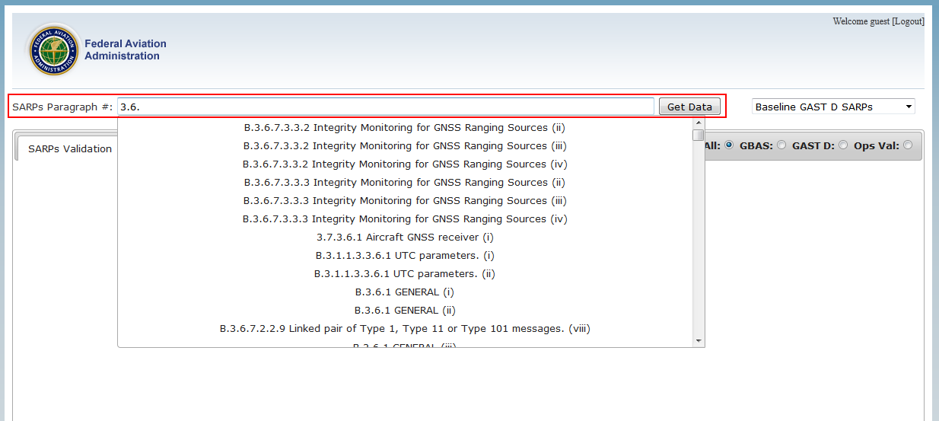

- The next two illustrations show a standard entry for a ‘shall’. The left side of the screen contains a PDF of the document, which highlights and auto scrolls to the specific “shall”.

- The right side has all of the necessary fields to complete validation, and the POC is the only person that has access to edit these. All other users have read-only access to the right side of the page.

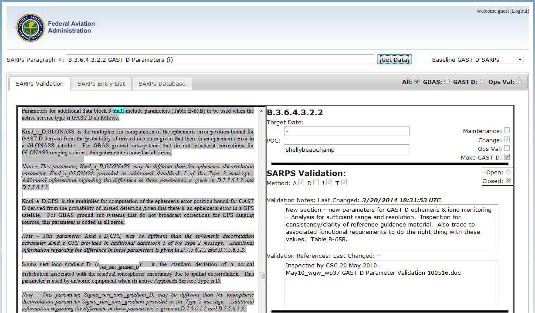

- The illustration below is a continuation of the previous one. You can see the extra fields on the right with the Submit Changes button below.

- On the left side of the page, under the PDF, there is a comment section that is available to all users (except guest). Once the user clicks Submit Comments, the comments are time stamped in the box shown below and emailed to the POC to alert them of the update.

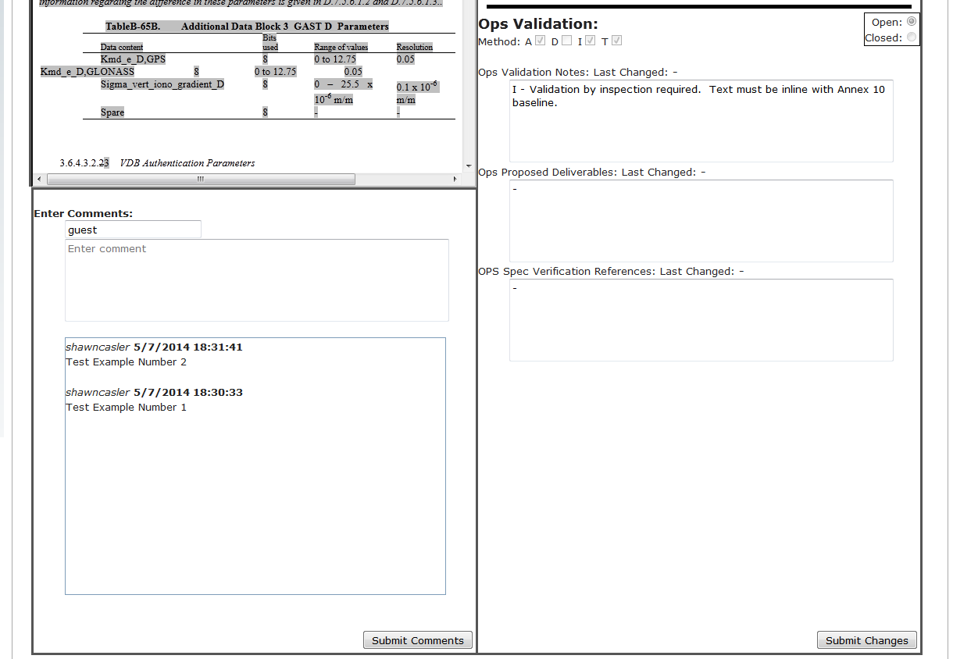

4 Tab Two – SARPs Entry List

- The next feature is the SARP Entry List tab. This lists all of the entries within each document.

- The user can sort by columns to make browsing easier.

- The Edit button on the right opens the corresponding requirement and brings the user back to the SARPs Validation tab.

- The button labeled Get Personal SARPs List will match the current logged in username to the requirements, where that user is labeled as the POC, making it easier to manage.
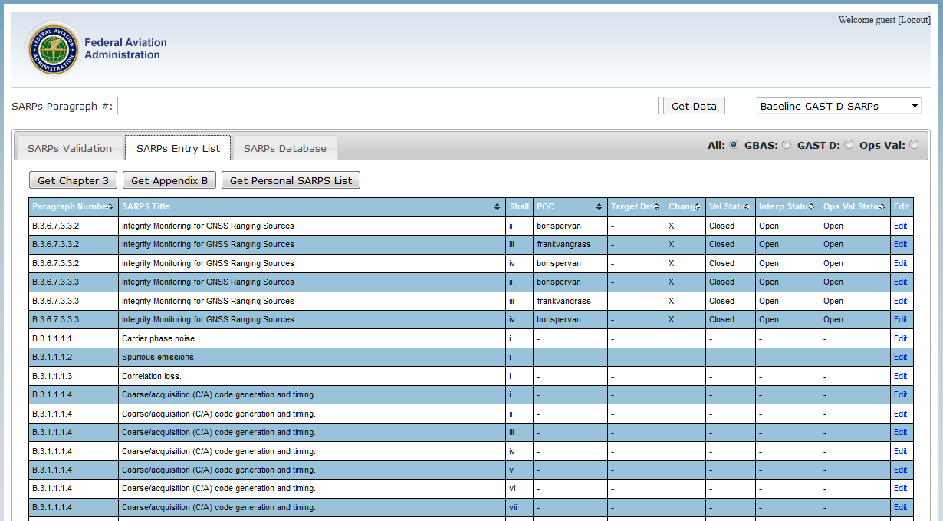

5 Tab Three – SARPs Database

- The SARPs Database tab retrieves the entire backend database in a .csv format.

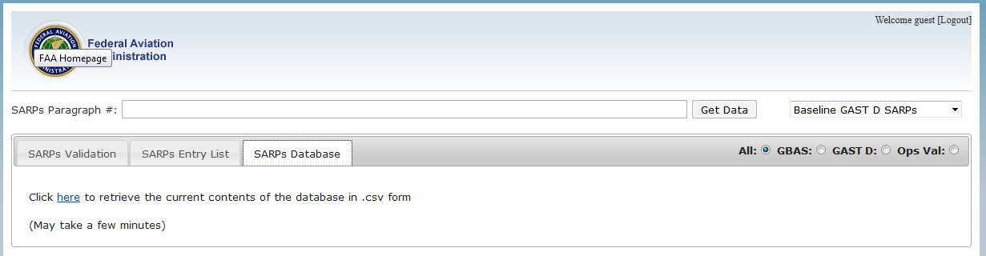

- Below is an image of the .csv file opened in Microsoft Excel

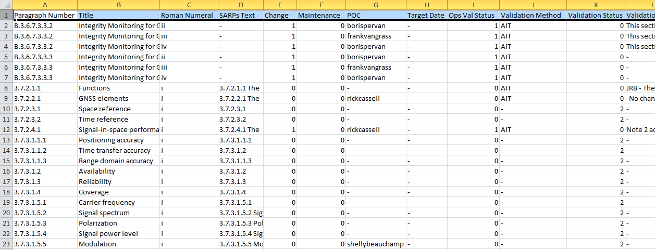

For those that choose to access the tool the following people can be contacted if there are any issues or questions:

- Shawn Casler | 609-485-6914 | Shawn.casler@faa.gov
- Shelly Beauchamp | 609-485-8358 | Shelly.Beauchamp@faa.gov
- Ruben Velez | 609-485-5452 | Ruben.Velez@faa.gov

6 RECOMMENDATION

The CSG is invited to consider whether the FAA GAST D SARPs validation tool would be a useful tool to support the CSG validation activities or the documentation for the validation matrix.

REFERENCES

- ICAO NSP WGW/Flimsy 29, “Development Baseline SARPs Proposal,” Montreal, May 2010.
- ICAO NSP CSG/WP26, “GBAS SARPS Maintenance Package as of Nov 12th 2013,” Montreal, November 11-21, 2013.

